Qno1. Create a directory ‘project_dir’ & cd to ‘project_dir’.



Cd project dir

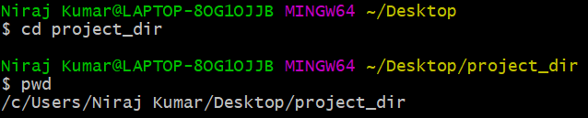

Q2. Initialize git version database.



Q3. Create a new file index.html



Q4. Check the git status. You should find index.html as untracked file.

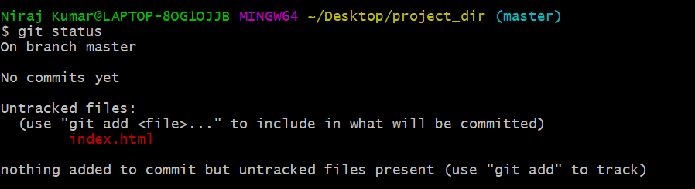

Q5. Stage the index.html file.



Q6. Commit index.html

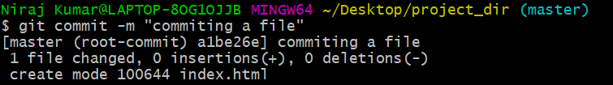

Q7. Make few changes in index.html & create a new file info.txt file

Q8. Check git status. You should find index.html & info.txt as untracked files

This Screenshots contains answer for both ques 7 and ques 8.

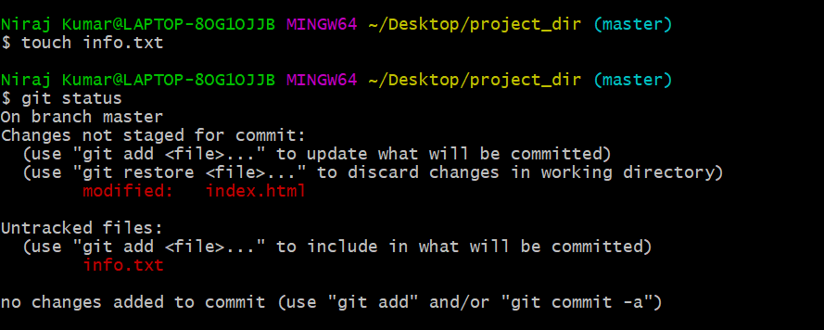

Q9. Configure GIT to ignore all txt files.

Q 10. Again check the git status. You should find only index.html as untracked file.

Both ans are in single screen shots.

Ans : I have created a directory gitignore to ignore all txt files.

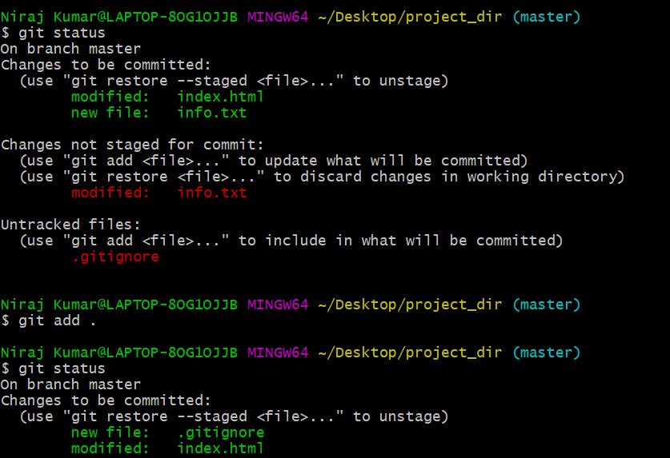

Q11. State & commit index.html

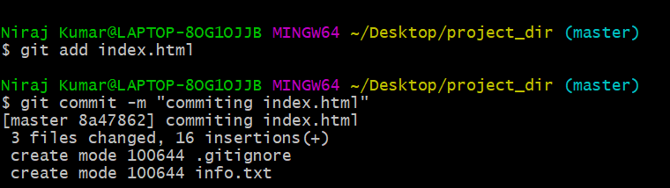

Q12. Log all your comments so far

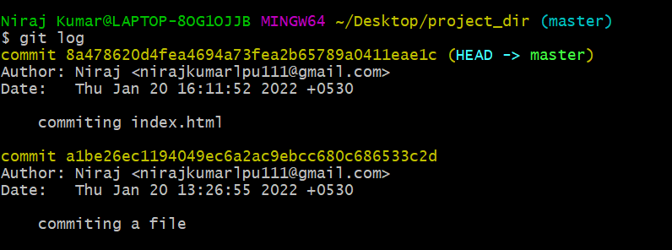

Q13. Make some changes in index.html

Q14. Revert the change made in the previous step using git command

Q15. . Again change index.html

Q16. Stage index.html

Q17. Revert back the last stage

This screenshots contain all these 3 ques. First I made change then staged it , committed and after that again reverted.

Q18. 8. Rename ‘add’ command to ‘my-add

Q19. Using my_add command Stage index.html again & commit the changes.

Q20. Revert the last commit.

Q22. Create an empty directory ‘Assignments’ & cd to ‘Assignments’.

Explanation : First I created a directory assignment

And after that I moved to my assignment directory using cd command.

Q23. Create a file README.txt inside ‘Assignments’ & write few lines about the contents of ‘Assignments’ folder.

Q24. Commit README.txt file.

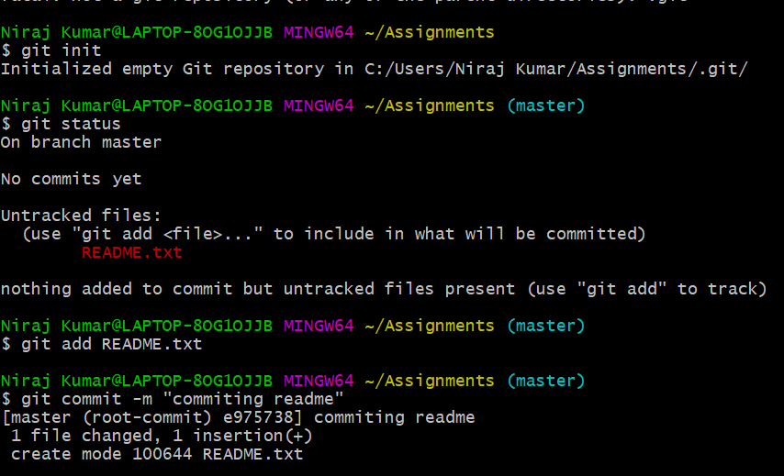

Q25. Now create a new branch ‘html-assignments’.

Q26. Switch to ‘html-assignments’ branch.

Q27. Copy all HTML assignments inside ‘Assignments’ folder.

Q28. Commit HTML assignments into ‘html-assignments’ branch

Q29 . Make minor changes into few files belonging to ‘html-assignments’ branch

Q30. Commit those changed file

Explanation

First I have worked upon master branch and then on assignment branch

Both the changes are mentioned below in screen shorts of visual studio code.

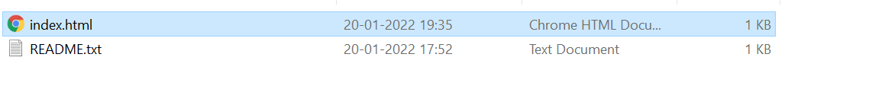

Q31. Switch to master branch

Q32. Make minor changes into README.txt file & commit those changes into master.

Q33. Again switch to ‘html-assignments’ branch

Q34. Make minor changes into few files belonging to ‘html-assignments’ branch.

Q35. Commit those changes

Q36. Switch to master.

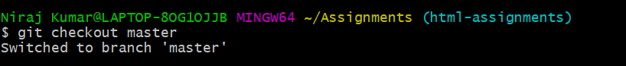

39. Create a github account if you do not have already.

40. Login on into github account.

41. Create new public repository ‘freshersbatch-oct16’.

42. Commit & push any sample file to this repository under ‘Assignments’ directory

Explanation: First created a repository then linked it to git and finally push the file to repository using push command.

